CHAPTER 4: Ecosystems
Worksheet 4.4

Nature pyramids
Science Quest 7: pages 122–127
Answers

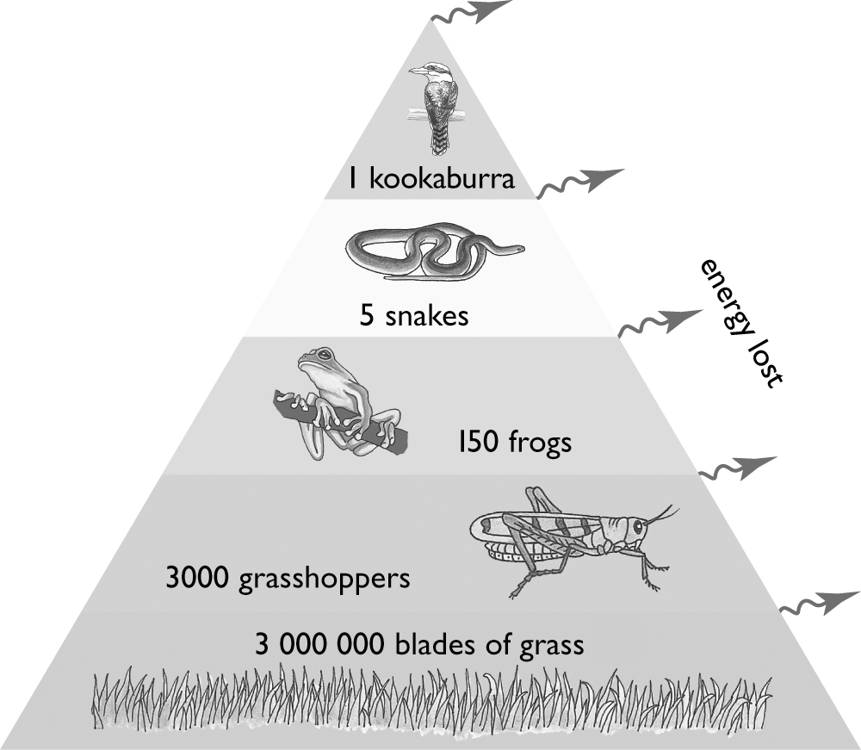
Questions
Fourth-order
consumers – kookaburra
The following questions relate to the food chain described in the numbers pyramid at right.
1. On the pyramid, label the producers and the order of consumers.
Third-order
consumers – snakes

2. Energy flows from the producers in a food chain to each other level in the chain. At each level, 90 per cent of the available energy is transferred to the environment, and so is not available to be passed on to the next level. If 100 per cent of energy is available at the producer level of the food chain, what percentage is available for the organisms at each other level of the food chain? Display your answers in the form of an energy pyramid.
First-order
consumers – grasshoppers
Producers – grass

Second-order
consumers – frogs
The bottom level of the pyramid should show available energy as 100%, the second level 10%, the third level 1%, the fourth level 0.1% and the fifth level 0.01%.

3. There are five organisms represented in this food chain. Explain, in terms of the energy available at each level, why food chains with five or more levels are rare.
Food chains with 5 or more levels are rare because only a small proportion of the energy available at each tropic level is passed onto the next level. This loss of energy limits the length of the food chain.

4. Look at the numbers of each organism at each level of the food chain. Why are the numbers much larger at the bottom than at the top?
The numbers are much larger at the bottom of the food chain as each organism requires less energy to survive and there is a larger amount of energy available in the lower levels of the pyramid.

CHAPTER 4: Ecosystems PAGE 2
Worksheet 4.4

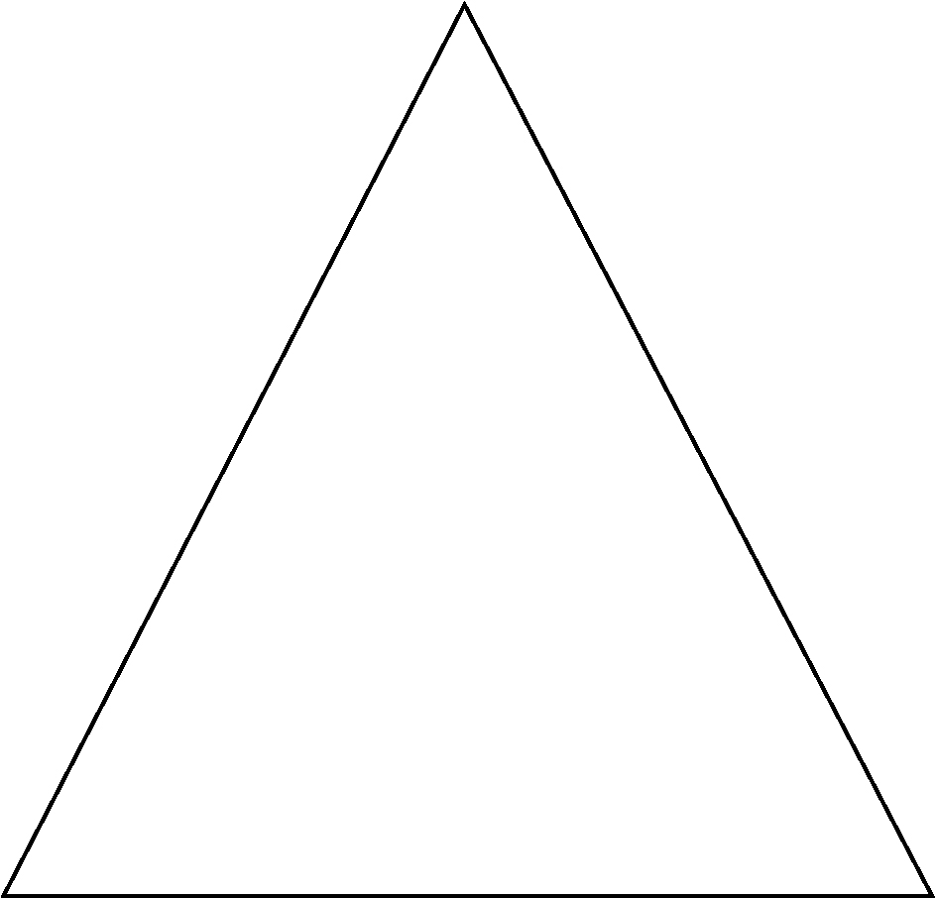
5. Using the numbers pyramid as a guide, sketch an appropriate biomass pyramid for the food chain.
Student answers will vary depending on their understanding of the mass of each organism in the food chain. Reality is that biomass of frogs will be larger than that of grasshoppers and biomass of snakes will be larger than that of kookaburra.

6. A farmer wishes to destroy grass on his farm using a poisonous substance. The manufacturer claims that the recommended dosage is not harmful to insects; that is, a grasshopper can ingest 0.1 milligrams of the poison without being harmed. It is known that animals can, however, become seriously ill if they ingest 0.2 grams of the poison and could die from ingesting 0.5 grams. Using the numbers pyramid above to aid in your calculation, describe how the kookaburra would be affected by the poison after eating five snakes.

If the grasshopper has ingested 0.1mg of poison and each frog eats 20 grasshoppers, one frog will contain 2mg of poison. If each snake eats 30 frogs that have eaten poisoned grasshoppers then a snake will contain 60mg of poison. Eating 5 snakes means the kookaburra has ingested 300mg or 0.3g of poison which means that it will be sick but should not die.

7. To avoid poisoning any animals, the farmer in question 6 decides, instead, to use a non-toxic weed killer to kill off the grass in a section of his farm. How will this affect the survival of the kookaburra? Explain your answer.
If the farmer uses a non-toxic weed killer to kill off the grass in a section of his farm it should not affect the survival of the grasshopper as the grasshopper can eat other plant material or move to other areas of the farm to eat grass. As long as the grasshoppers can still eat and reproduce the rest of the food chain should not be affected.

